Curriculum Vitae (C.V.)
- Personal data:
Name (Arabic) | سلمى فرحات على احمد
Name (English) | Salma Farhat Ali Ahmed
Department | Anesthesiology, surgical icu and pain medicine
College | Faculty of medicine- banha university
Academic degree | Masters
Office Address | Banha university hospital- banha -Qalubya
Mobile 1 | 01026981569
Home phone | -
Email (university)
Email (alternative) | doc.salma.ismail@gmail.com
Web site (if any) | -
Recent Photo (passport format) | 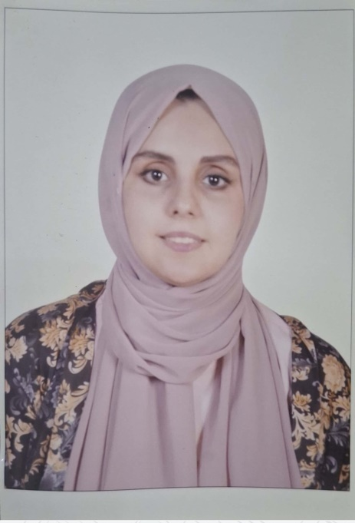

- Education:
2.A. Degree obtained;
Institution | Degree obtained | Year
Faculty of medicine- Mansoura university | MBBS | 2015
Faculty of medicine- Mansoura university | Masters degree of anesthesiology and surgical icu | 2022

2.B. Specialty;
General specialty. | Anesthesiology
Specific specialty. | -

2.C. Language skills (Excellent, Very Good, Good or Basic);
Language | Reading | Speaking | Writing
Arabic. | Native | Native | Native
English. | Excellent | Excellent | Excellent
French. | - | - | -
Other (specify). | - | - | -

- Positions:
Tittle | Year | University/Institution
Resident in anesthesia department | 2018-2021 | mansoura university hospital
Assistant lecturer in anesthesia department | 2023-present | Banha university hospital

- Cooperation with local and international entities having website:
( جامعة – مؤسسة - وزارة – مركز بحثي – عضو هيئة تدريس – باحث - شركة – مصنع – الخ)
Name of local and international entity | Website
- Membership of professional bodies (List):

- Membership of institute (List):

- Distinction and Awards (List):

- Academic:
Courses at under graduate level;
1. Course name: | Clinical rounds;
2. Course name: | Lectures;
Courses at post graduate level;
- toefl | - basic abdominal us course
- icdl | - acls
- Areas of research:
-Anethesia
-intensive care medicine
-pain medicine
- PhD/M.Sc Supervision:
Title | PhD/M.Sc | Year completed / in progress
Comparison between Effect of Dexmedetomidine and Dexamethasone as an Additive to Subtenon Block with General Anesthesia on Perioperative outcomes for Pediatric Strabismus Surgeries | M.Sc | 2022

- Grants for Projects:
Funding organization | Project title | Role | Year
- Committees:
-
- List of Publications:
The Egyptian journal of hospital medicine
Article 148, volume 92, issue 1, july 2023, page 6440-6448
Comparison between Effect of Dexmedetomidine and Dexamethasone as an Additive to Subtenon Block with General Anesthesia on Perioperative outcomes for Pediatric Strabismus Surgeries
https://ejhm.journals.ekb.eg/article_314508_42191.html
14. Attended Workshops, Symposiums, and Conferences: "List name and year";

Name of Workshops, Symposiums, and Conferences | Year
13th Mansoura Anaethesia conference | 2018
14th Mansoura Anaethesia conference | 2019
16th Mansoura Anaethesia conference | 2021

- Books published:
-
16. Positions:
 | Date | Organization | Country | Position
1 | - | - | - | -

17. Activities in faculty/university/community service:
Name of Activity service | Year
- Teaching (Rounds and lectures). | -
- Clinical meeting. | -
- Making conferences. | -
- Medical Convoys. | -
- Workshops.
18. Consulting Experience (if any):
-
19. Additional information you would like to put on the website:
-

